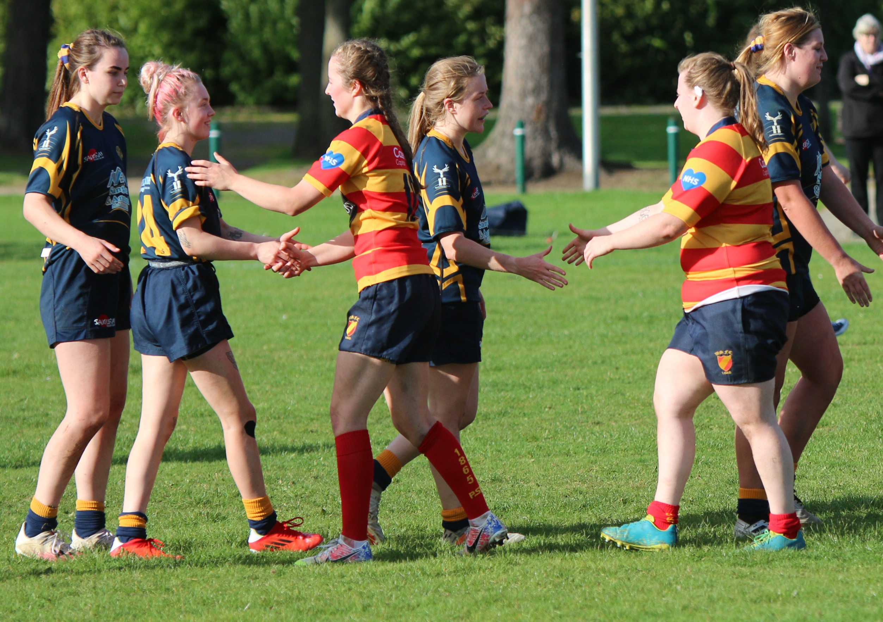
Kick-Off Times Season 2022-2023
Kick-Off Times Season 2022-2023

MEN’S LEAGUE FIXTURES
Up to and including 29th October 2022 3pm
30th October 2022 up to and including 18th February 2023 2pm
Remainder of Season 3pm

MEN’S KNOCK OUT CUP FIXTURES
(where allowance required for extra time)
Up to and including 29th October 2022 3pm
30th October 2022 up to and including 18th February 2023 1.30pm
19th February 2023 up to and including 25th February 2023 2.30pm
Remainder of Season 3pm

WOMEN’S LEAGUE FIXTURES
All season

WOMEN’S KNOCK OUT CUP FIXTURES
(where allowance required for extra time)
Up to and including 29th October 2022 2pm
30th October 2022 up to and including 25th February 2023 1.30pm
Remainder of Season 2pm

KICK-OFF TIMES ON INTERNATIONAL MATCH DAYS -
As per NCR 3.3 - Matches taking place on the same day as a home international played by the senior men’s Scotland team shall kick-off no later than 2 hours prior to the international match kick-off.

